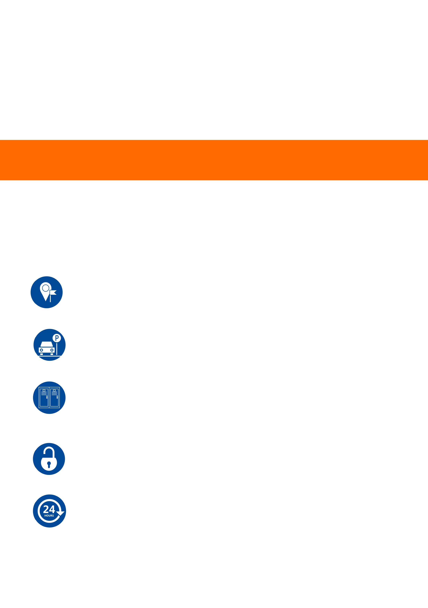





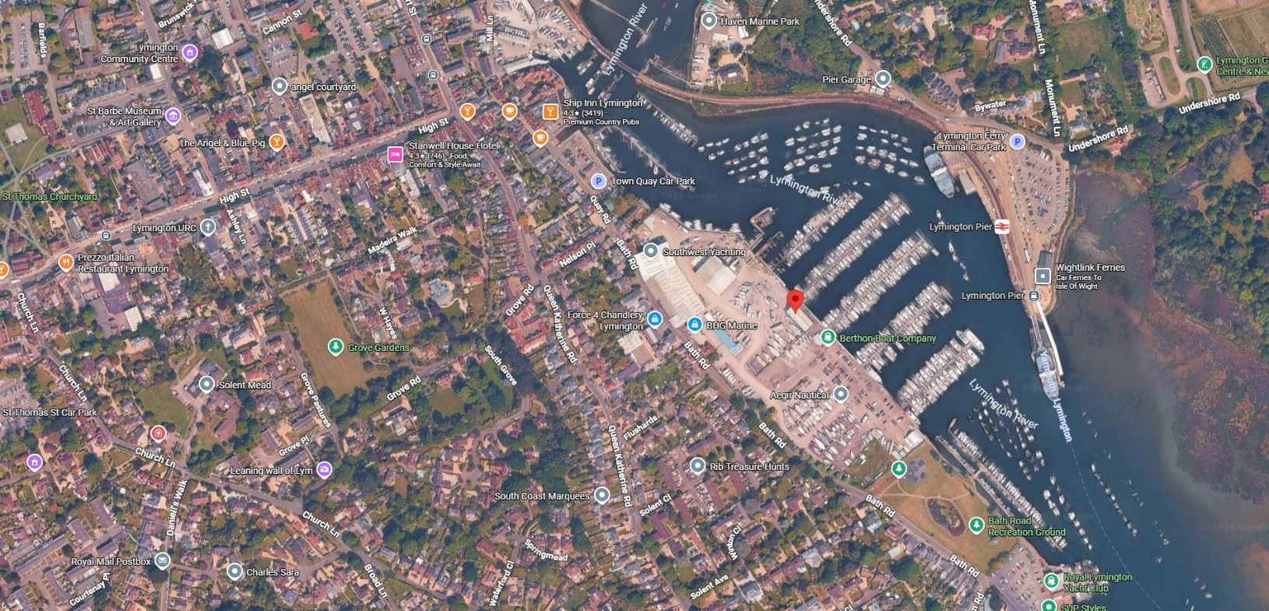
Imagery ©2026 Airbus, Maxar Technologies, Map data ©2026 Google
50
m

Marina
Building
Directions
Save
Nearby
Send to
phone
Share
At this place






Bath Rd, Lymington SO41 3YL
Marina
Parking
Parking is
FREE
and you can drive down to the office if possible if not there is parking on site to the right of the office.
Access times
Access to the storage area is 7 days a week 24hrs
To view the location please click below
https://maps.app.goo.gl/or1TxhvfNzFbYh1u6

Padlock Access Code

Key Acces via Dockmaster Office

Arriving at the Marina
Enter via the main entrance off Bath road.
Car Park is to the right and turn 1st left through the boat yard to park on the left side of the mariner office, or take the 2nd left just after Aegir Nautical to park at the onsite car park
Storage Location | Cage
D Corridor, D1 Cage
Our cage is located at the rear of the Marina Office

COLLECTION
AND DROP OFF
Liferaft Servicing
Lifejacket Servicing
Marine Equipment Supplies
Suffolk Marine Safety have a secured a cage at the rear of the Berthon Marina Office,
W Dock master Officer near to a boat
When parked up, you make your way in that direction, and look for the dock master’s office to obtain the key and locate the cage in D Corridor D1 Cage.

You must return the key to the dockmasters office once unloaded or collected.
T:
01473 833010
E:
enquiries@suffolkmarinesafety.com
www.suffolkmarinesafety.com
Open Weekdays 8:30-5:30
|
Excluding Bank Holidays
BERTHON LYMINGTON MARINA

The Shipyard, Bath Road, Lymington, Hampshire, SO41 3YL

